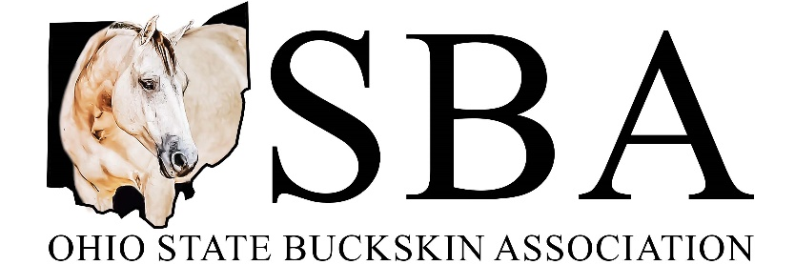

2024 Trail Riding Program
Ideal for the Buckskin horse enthusiast who enjoys the open spaces of the trails and woods, OSBA offers an alternative to the show ring - a way to earn points towards great year-end awards with your IBHA-registered horse (Buckskin or Buckskin Bred) or OPEN Horse!! Check out the information below and get ready to hit the trails!

Year-End Award Rules:
- For the Buckskin division the horses must be registered with IBHA (Buckskin or Buckskin Bred)
- Buckskins and Buckskin Bred horses will be in the same division
- Rider must be a current member of the Ohio State Buckskin Association
- Nomination form must be submitted by April 30th
- Nomination fee is $15 for adult riders and $10 for youth riders
- Year-end awards are based upon the number of hours logged from April 1st – October 31st
- Hours logged may include any riding time that is not done as part of a formal training program or in a show arena
- Nominees should use the official OSBA Trail Riding Log to submit their records to the Trail Riding Program Coordinator (form is on the OSBA website)
- Trail riding hours must be submitted by November 6th either by mail or email
- Year-end awards will be given to first through third place in each division, based on total number of hours logged for each rider (multiple horses allowed per rider)
- NEW DIVISON THIS YEAR WILL BE OPEN HORSES!! EVEN IF YOU DON’T HAVE A BUCKSKIN, YOU CAN PARTICAPATE IN EARNING SOME AWSOME AWARDS!!

Questions/Comments may be directed to the Trail Riding Program Coordinator:
Carmen Kellenbarger Porter – supershifter363@gmail.com – (704) 877-1910

Ohio State Buckskin Association
2024 Trail Riding Program Nomination Form
Name: _______________________________________________________________
Address: _____________________________________________________________
Phone Number: ___________________ Email Address: _______________________
Adult (19 years of age or older as of January 1st) $15
Youth (18 years of age or under as of January 1st) $10
Please make checks payable to OSBA and submit form and payment to:
Heather Nigg, (OSBA Treasurer) – 947 Millville Oxford Road, Hamilton, OH 45013

REC _______ DATE _______ CK # ________ AMT _________

