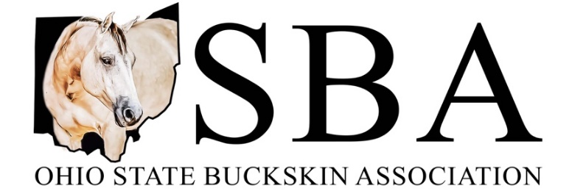

Come join the fun and be part of a family you never knew you needed!
The Ohio State Buckskin Association, chartered by the International Buckskin Horse Association in 1986, is dedicated to the preservation and promotion of registered Buckskin, Dun, Red Dun, and Grulla horses in Ohio and surrounding states. With an outstanding Youth and Youth Walk-Trot program, a dynamic Amateur and Select Amateur program, and many of the most competitive open performance horses and exhibitors in the country, we welcome your interest in our activities.
We are deeply committed to serving the interests of buckskin owners both in and out of the show arena, the breeding shed, and also in the “backyard”.

Becoming an OSBA member offers many opportunities to enjoy and promote Buckskins, which include:
- One of the best Year-End Award programs in any IBHA charter, offering awards in Youth, Youth Walk-Trot, Amateur, Select Amateur, and Open
- A Trail Riding program for those who would rather enjoy their buckskins at home & on the trail
- The Buckskin Memorial Classic, held in memory of George Anders, to kick off to the Ohio Buckskin Circuit and earning year-end awards
- The highlight of the show season, the Red, White, & Buckskin Circuit held in memory of Deb Mathews near the Fourth of July, with fun-filled family activities and lots of good food!
- Youth Team participation at the IBHA World Show, held in Cloverdale, Indiana. This is a chance for youth from across the country to compete in the arena as well as in the barn for a stall decorating contest
- Miss OSBA and Miss Buckskin World competition for young ladies ages 17-24
- Youth Scholarships awarded through IBHA
- The OSBA website – www.ohiobuckskins.org – a great source of all OSBA information!

The officers and members of the Ohio State Buckskin Association encourage all who share our love of the beautiful and durable Buckskin horse, and also are looking for fun, fellowship, and competition with friendly, family-oriented horse lovers, to join us as we grow in strength and quality.

OSBA MEMBERSHIP APPLICATION - ($5 Late Fee after March 1st)

Adult (over 19 years of age) $20.00 _______
Youth (18 and under) $10.00 _______
Family/Farm/Partnership (carries two votes) $30.00 _______
Lifetime Membership $150.00 _______

*PLEASE NOTE: YOU MUST BE AN OSBA MEMBER PRIOR TO OUR FIRST SHOW FOR YOUR POINTS TO COUNT TOWARD YEAR END AWARDS*

Name: _______________________________________________________________
Address: _____________________________________________________________
Phone Number: ___________________ Email Address: _______________________

Please make checks payable to OSBA; Mail to Heather Nigg, OSBA Treasurer, 947 Millville Oxford Road,
Hamilton, OH 45013 or email ohiobuckskins@gmail.com for more information

REC _______ DATE _______ CK # ________ AMT _________

