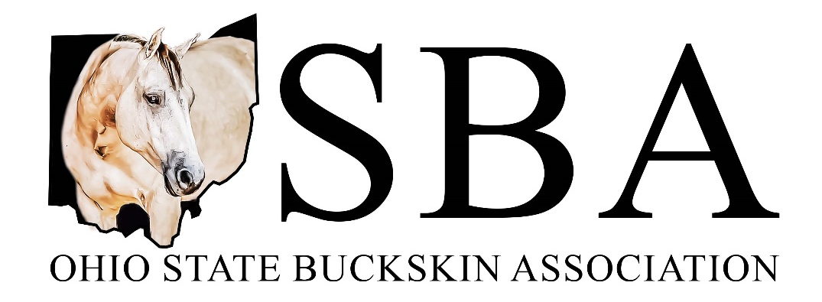

The Ohio State Buckskin Association is the Ohio chapter of the International Buckskin Horse Association, a registry for buckskin, dun, red dun, and grulla horses and miniatures. We offer approved shows for eligible horses for national points, year-end awards and a trail riding award program. We are holding two shows this year; the Buckskin Memorial Classic on May 18-19 (2 full day shows) at the Preble County Fairgrounds in Eaton, Ohio and the Red, White and Buckskin show July 7-8 (split/combined) at the Champions Center in Springfield, Ohio. We take great pride in being a family based equine association.

OSBA is currently seeking sponsors for both of our shows this year. Our sponsors enjoy recognition on our website, www.ohiobuckskins.org, and Facebook page. Additionally, various daily announcements are made on behalf of sponsors throughout the show days over the PA system. We are looking for monetary donations in addition to products that can be used as awards, silent auction items, and door prizes for exhibitors.

Thank you in advance for considering OSBA’s request for sponsorship. Attached is a sponsorship form for your convenience. If you should have any questions, please feel free to contact me by phone at (419) 957-7485 or by email at allimanequinecenter@gmail.com.

Sincerely,

Brenda Alliman
OSBA President

2024 Sponsorship Form

Sponsorship Levels
Platinum: $200 * Gold: $100 * Silver: $50 * Bronze: $25

Name/Business:

Address:

City: State: Zip:

Phone:

E-Mail:

Amount of Sponsorship:

Product/Merchandise:

Class you would like to sponsor:

Class in memory of (if relevant):

Please make checks payable to OSBA and submit form and payment to:
Heather Nigg (OSBA Treasurer) – 947 Millville Oxford Road, Hamilton, OH 45013

REC _______ DATE_______ CK # ________ AMT _________

OSBA thanks you for your support!
www.ohiobuckskins.org

